“let us walk in the light of the Lord!” (Is 2:5)
“No one pours new wine into old wineskins. Otherwise, the wine will burst the skins. And both the wine and
the skins are ruined. Rather, new wine is poured into new wineskins.” (Mk2:21-22)
“It seems important that we underline that at the foundation of every journey is the need of a new thrust toward holiness on the part of consecrated men and women. This is unthinkable without an impulse of renewed passion for the Gospel at the service of the Kingdom. The Spirit of the Risen One who continues to speak to the Church with his inspirations moves us along this journey. (NWiNW 10)
The good wine and the new wine thus symbolize Jesus’ behavior and teaching which cannot be contained in the old wineskins of centuries-old religious schemes which are incapable of opening up themselves to new promises (NWiNW2)
The Lord Jesus’ word helps us assume the challenge of a newness which demands not only acceptance but also discernment. It is necessary to create structures that are capable of safeguarding the innovative richness of the gospel so that it can be lived and put at the service of while preserving its quality and goodness. (NWiNW2)
In other translations the word for “new” is translated as “fresh”. The word “fresh” can be used to describe the wineskin used to contain new wine. A fresh wineskin can be a new wineskin but it can also refer to an old wineskin that has been reconditioned. A reconditioned wineskin is as supple as new and is able to hold new wine. To recondition it, an old wineskin needs to be cleaned and then soaked in oil. The wineskin is soaked until it is rejuvenated to its supple and soft state to be ready for the new wine. So old wineskins are not thrown away or only being used to hold old wine. It can be made fresh again to hold new wine!” (Pauline Johnson)
With the October Amazonian Synod the members of the church were asked to consider a new face for the church, one with the features of the Indigenous peoples. Who are these indigenous peoples who are to help us change the face of the Church?
As the Amazonian indigenous peoples seek life in abundance this takes the form of what they call ‘good living’, and is fully realized in the Beatitudes. It is a matter of living in harmony with oneself, with nature, with human beings and with the supreme being, since there is intercommunication within the whole cosmos, where there are neither exclusions nor those who exclude, and where we can forge a project of full life for all. Such an understanding of life is characterized by the connectedness and harmony of relationships between water, territory and nature, community life and culture, God and various spiritual forces. For them, ‘good living’ means understanding the centrality of the transcendent relational character of human beings and of creation, and implies ‘good acting’ too. This integral way is expressed in their own way of organizing that starts from the family and the community and that embraces a responsible use of all the goods of creation. Indigenous people aspire to better living conditions, especially in health and education. They want to enjoy the sustainable development that they themselves choose and shape and that maintains harmony with their traditional ways of life, in a dialogue between their ancestral wisdom and technology and the new ones acquired. (9) Amazonia: New Ways for the Church and for an Integral Ecology

In a recent meeting with CLAR, the religious men and women of 22 countries in Latin America and the Caribbean shared the symbol of the wedding feast of Cana and discussed the new wine being put into each of the jars. The following petitions ask for the graces being sought from the fermenting of the new wine.

Let us pray in response: Lord, tenderize our hearts and spirits to receive your new inspirations.

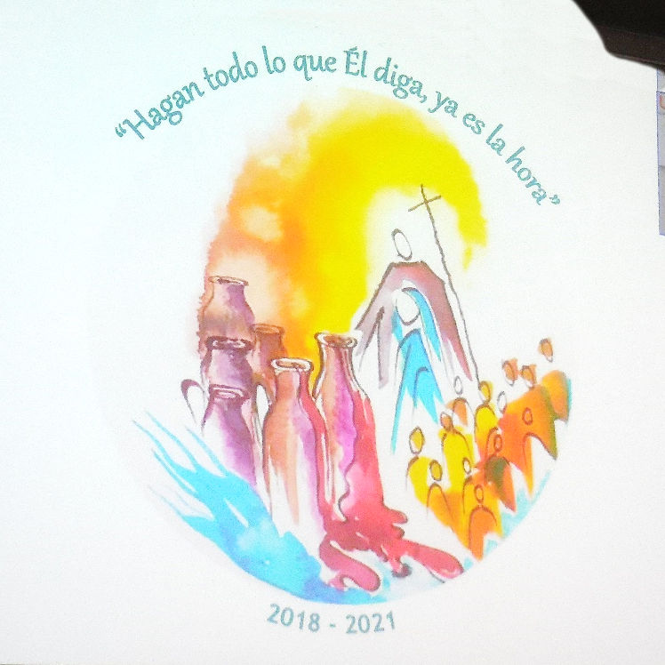
- That our discernment of what is ours to do focuses on the centrality of evangelization. And, that this source deepens our enthusiasm for what is essential to live the Gospel.

- That we embody the spirituality of the Trinity, unity in love. And that divine life is the source of our dynamic communion, with God, self and all of creation.

- That we take to heart, the call for conversion. And, through our affective and effective actions bring about reconciliation in communities.

- That embracing Mary as our Mother and model of discipleship, we contemplate the meaning of our lives. And, that we consider new ways to be Church by building bridges and honoring the martyrs who surrendered their lives for the excluded.

- That we consider the ethics of encounter with the cities. And that we develop pastoral plans where the Gospel is always present and the source of our relations.

- That we embrace a comprehensive integral ecology situating ourselves on the side of those who defend life. And, as we listen to the cry of the Earth and the cry of the poor we are able to develop an integral ecology. (Petitions reflective of the CLAR presentation on their symbol of the Wedding Feast of Cana for their planning)

Prayer: Lord, help us to identify with and remember the values deeply rooted in indigenous peoples in the way that Pope Francis raises up their contributions “to instill a greater sense of responsibility, a strong sense of community, a readiness to protect others, a spirit of creativity and a deep love for the land.” And that they and we are also concerned about what we will eventually leave to our children and grandchildren.” (LS 179)
Link for Casa Comun Song
