World Day of Migrants and Refugees Prayer 2020

HISTORICAL INTRODUCTION:
The celebration of this Day has its origin in 1914, a few months before the outbreak of World War I, when Pope Pius X, touched by the drama of millions of Italians who had migrated abroad, called on all Christians to pray for migrants. Later, his successor, Pope Benedict XV, instituted the "Day of the Migrant" to support spiritually and economically the pastoral works with these people.
In 1952, Migrant Day took on a broader and more international connotation and the particular Churches were called upon to choose a date to celebrate this day during the liturgical year.
In 2004, the Pontifical Council for the Pastoral Care of Migrants and Itinerant People extended the Day to include Refugees.
At the request of several Episcopal Conferences, Pope Francis placed the World Day of Migrants and Refugees on the last Sunday of September.
On September 27th of this year 2020, we celebrate the 106th World Day of Migrants and Refugees.

ENVIRONMENT: Let’s place images with the eyes of people of different races.
* Before the prayer, if possible, let’s see the following video:
https://youtu.be/Y8rq1RQH5PE
MOTIVATION: according to the latest data available from the GRID (Global Report on Internal Displacement), in 2020 the world's displaced people number 50.8 million. Of these, 45.7 million have left their homes due to armed conflict, rape of all kinds and the others due to natural or man-made disasters.
In the silence of prayer, let these facts and the faces of so many displaced persons and migrants living around us impact us and pass through our hearts. Let us make it present to the Lord and open our hearts to His Holy Spirit, so that He may teach us to look, feel and act like Jesus.
INITIAL SONG: LA VOZ DEL SILENCIO. Salomé Arricibita.

https://www.youtube.com/watch?v=2acQoulSk0A

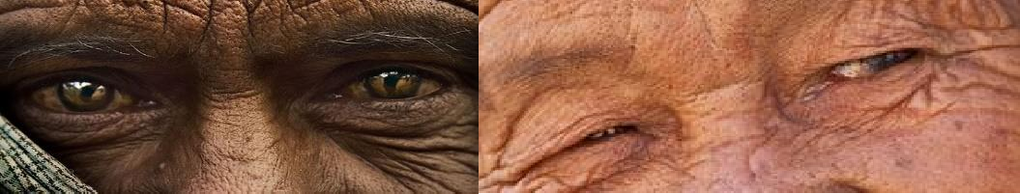
We invite you to recite the psalm spontaneously, feeling ourselves like the voice of the voiceless...migrants, displaced persons, men, women and children who suffer from this condition, recognizing that God cares for each one. PSALM 23: “THE LORD IS MY SHEPHERD”

The Lord is my shepherd; I shall not want.  He makes me to lie down in green pastures.  He leads me beside the still waters, He restores my soul; He leads me in the paths of righteousness for His name’s sake.  Yea, though I walk through the valley of the shadow of death, I will fear no evil; for Thou art with me; Thy rod and Thy staff, they comfort me. | You prepare a table before me in the presence of mine enemies; Thou anointest my head with oil; my cup runneth over.  Surely goodness and mercy shall follow me all the days of my life; and I will dwell in the house of the Lord forever.

AT JESUS SCHOOL
Let us be touched by the words and gestures of Jesus in the Gospel of
MATTHEW 25, 34 - 35.40
"Come, you who are blessed by my Father; take your inheritance, the kingdom prepared for you since the creation of the world. For I was hungry, and you gave me something to eat, I was thirsty and you gave me something to drink, I was a stranger and you invited me in.
Truly I tell you, whatever you did for one of the least of these brothers and sisters of mine, you did for me".

CLARET'S WAY OF ACTING

S. ANTHONY MARY CLARET:

As Archbishop of Santiago de Cuba, he worked tirelessly, missioning, sowing love and justice on that Island where racial discrimination and social injustice reigned everywhere. He stood up to the foremen, he tore the whip out of their hands. One day he reprimanded a rich landowner who was mistreating some natives who worked on his farm. Seeing that the man was unwilling to change his behaviour, the Archbishop tried to teach him a lesson. He took two pieces of paper, one white and one black, set them on fire and pulverized the ashes in the palm of his hand. "Sir," he said, "can you tell me what the difference is between the ashes of these two pieces of paper? For that is how equal we are in the sight of God".

TIME OF PERSONAL REFLECTION

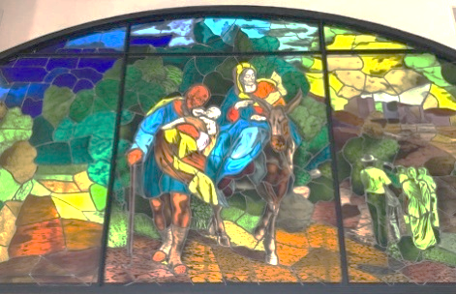

MESSAGE FROM POPE FRANCIS:
- You have to know in order to understand. When we talk about migrants and displaced persons, all too often we stop at statistics. But it is not about statistics, it is about real people! If we encounter them, we will get to know more about them. And knowing their stories, we will be able to understand them.
- It is necessary to be close in order to serve. Fears and prejudices keep us distant from others and often prevent us from “becoming neighbours” to them and serving them with love. Drawing close to others often means being willing to take risks, as so many doctors and nurses have taught us in recent months. Jesus gave us the greatest example of this when he washed the feet of his disciples: he took off his cloak, knelt down and dirtied his hands (cf. Jn 13:1-15).
- In order to be reconciled, we need to listen. In 2020, silence has reigned for weeks in our streets. A dramatic and troubling silence, but one that has given us the opportunity to listen to the plea of the vulnerable, the displaced and our seriously ill planet. Listening gives us an opportunity to be reconciled with our neighbour, with all those who have been “discarded”, with ourselves and with God, who never tires of offering us his mercy.
- In order to grow, it is necessary to share. The pandemic has reminded us how we are all in the same boat. The realization that we have the same concerns and fears has shown us once more that no one can be saved alone. To grow truly, we must grow together, sharing what we have.
- We need to be involved in order to promote. Sometimes the impulse to serve others prevents us from seeing their real riches. If we really want to promote those whom we assist, we must involve them and make them agents in their own redemption. The pandemic has reminded us of how essential co-responsibility is, and that only with the contribution of everyone can we face this crisis.
- It is necessary to cooperate in order to build. Building the Kingdom of God is a duty common to all Christians, and for this reason it is necessary that we learn to cooperate, without yielding to the temptation to jealousy, discord and division. In the present context it should be reiterated: “This is not a time for self-centeredness, because the challenge we are facing is shared by all, without distinguishing between persons”.

After a time of silence we share whatever has touched
our hearts and we can make spontaneous prayers.

LORD’S PRAYER:
Putting our migrant and refugee sisters and brothers in God's hands, we pray with the prayer that Jesus taught us…
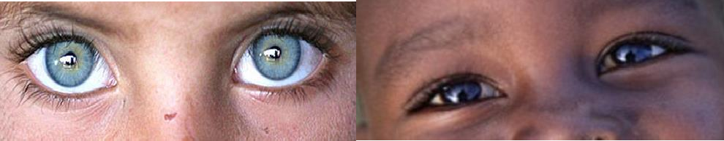

COMMITMENT:
Personally, we propose to look at our migrant and refugee brothers and sisters as God looks at his children, with love, tenderness, compassion, putting ourselves in their skin…
And as a group or community, we make a commitment in favour of migrants and refugees where we live.

What are we committing to do for the people on the move?…

Pause of silence

FINAL PRAYER: by Pope Francis

Father, you entrusted to Saint Joseph what you held most precious: the child Jesus and his Mother, in order to protect them from the dangers and threats of the wicked.

Grant that we may experience his protection and help. May he, who shared in the sufferings of those who flee from the hatred of the powerful, console and protect all our brothers and sisters driven by war, poverty and necessity to leave their homes and their lands to set out as refugees for safer places.

Help them, through the intercession of Saint Joseph, to find the strength to persevere, give them comfort in sorrows and courage amid their trials.

Grant to those who welcome them some of the tender love of this just and wise father, who loved Jesus as a true son and sustained Mary at every step of the way.

May he, who earned his bread by the work of his hands, watch over those who have seen everything in life taken away and obtain for them the dignity of a job and the serenity of a home.

We ask this through Jesus Christ, your Son, whom Saint Joseph saved by fleeing to Egypt, and trusting in the intercession of the Virgin Mary, whom he loved as a faithful husband in accordance with your will. Amen.

P. CRISTOBAL FERNÁNDEZ, Blessed Antonio M. Claret. T.1 p.764

